Christmas 2013

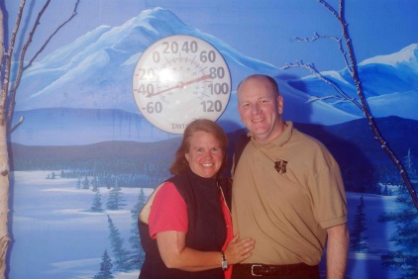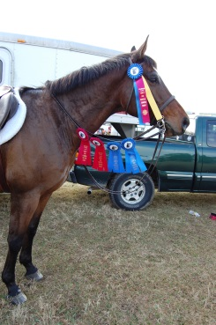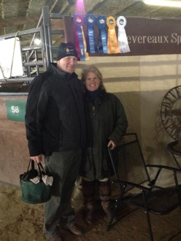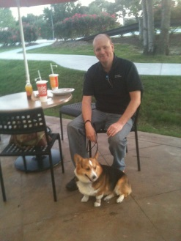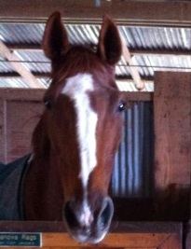
40 Below in Alaska First Show 2013 Last Show 2013 Cooper Cass

You might say the Year of the Horse arrived early at the Richardson, Wilson,
Cooper household. Malloy began showing in January, and has been splendid throughout.

In February, Diane and I took a romantic trip down to Galveston for Valentine's Day. We stayed in the once luxurious Casa Del Mar, with a balcony overlooking the coastline and a nearby gas station. We took a Segway tour of downtown tree sculptures and other aftereffects of Hurricane Rita by day, and laid in the master bedroom watching the septic Carnival Triumph dragged back to shore by night. It was one of those remember where you were kind of events. We made time for dinner at the Steakhouse at the San Luis hotel and a spa treatment for Diane, between coverage and the countdown to arrival for the Triumph.

In March we finally got to a live Lady Antebellum show at the Houston Rodeo. We had front center seating, as least for a minute, as the stage rotated around. Also in March, Diane went with Marian Taylor to Indio, California to see the HITS Desert Circuit Thermal $1 million Grand Prix.

In May came the announcement, after twenty years of rumors, that BMC Software was being acquired, by a group of private equity firms. This makes fifteen years with the same company, though the name, ownership and stock ticker change every now and again.

Late May also brought our big trip of the year. We began in Seattle to visit
Maya and Gia, before catching an Amtrak to Vancouver for the night, then boarding a Holland America cruise ship to travel the inner passage to see
Glacier Bay and then Alaska. After watching just what can go wrong with a cruise just months earlier, we were happy the cruise portion of the trip was just 3 days, and we rolled down the gangway relatively unscathed. A few more midnight buffets might have done us in. A few bus and train rides later we were at Denali Park, where we took a private plane ride around the mountain. It was supposed to be our first helicopter ride, so we could cover all modes of mechanized transport, other than submarine of course. But the helicopter was grounded for repairs.

When we got back in June, we shopped around for a replacement for Diane's 13 year old pickup truck. We did lots of research, test drove different options, and I would really like to say it was a close call, but the Chevy had a good size console for Cooper to sit in the front seat and well, the Ford didn't. Pish posh on the "Cowboy Cadillac", we opted for the Corgi Cadillac. We got a brown one that matches his collar too.
In July we took Malloy, Cooper, and the new wheels up to OKC for the GO Preview Show. They've got some nice facilities there. Air conditioned arenas. Judy flew in too. We had a pool party at the HoJo's.

In August, we flew up to Delaware, and went to the Meadowlands to see my first Hambletonian. We toured some local barns to see trotters get on in their natural habitat.

In the fall, we took to the arts, taking in "The Book of Mormon" musical in person, and "Tosca" opera remotely, in Italian with subtitles, popcorn, and liberal intermissions.

Malloy clinched the GHHJA year-end championship for Low Hunter in October, and put an exclamation point on it in the year-end show at GSWEC which is roughly our home court venue.

In the course of the year, we filled our hallway with ribbons, and I started a blog to chronicle the events from the horse husband's perspective. You can read it here.

http://www.amyheidbreder.com/profiles/wordpress/jesse/

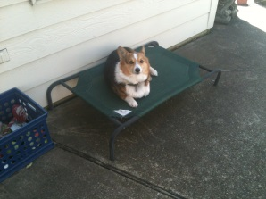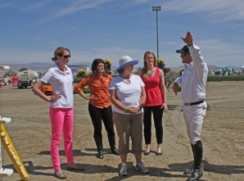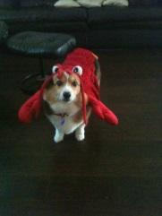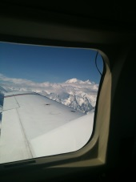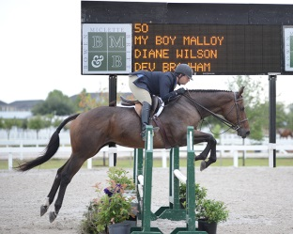

Cooper lounging Course walk in Indio Lobster Mt. McKinley Horse Show
with Olympian Corgi
Will Simpson

